1. First step is to write the website content or design

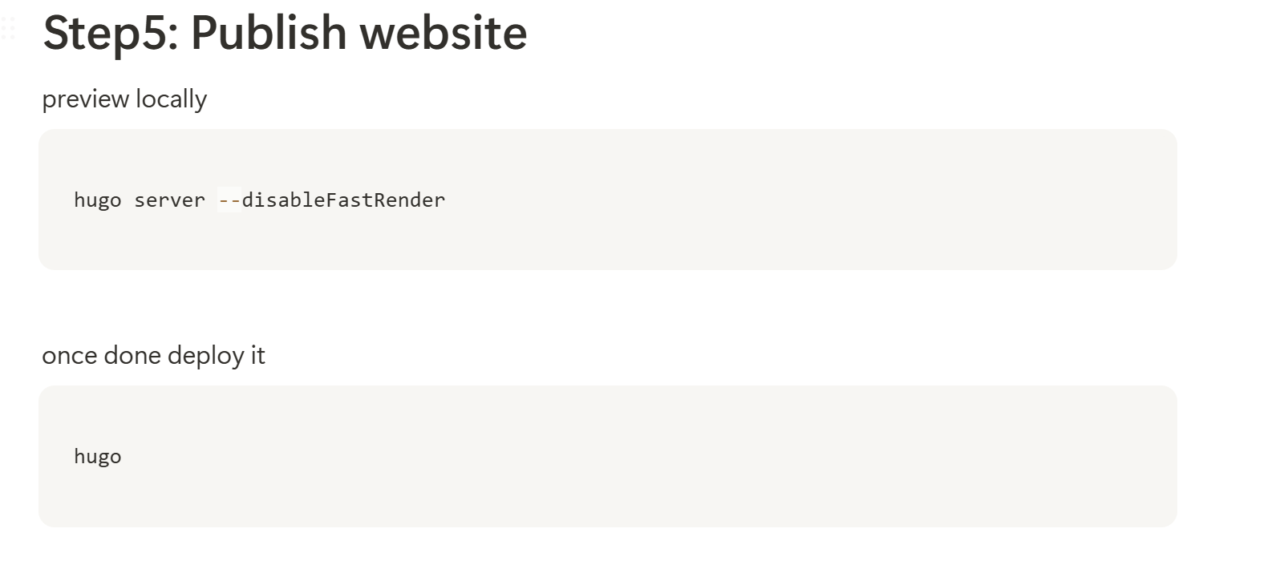

1. This is how we can publish the website content
2. Now the question is how can we enter the content in there
3. The first thing is your name and your picture
4. The front page must be the
5. According to the perplexity we can just go to the config for changing a lot of things there

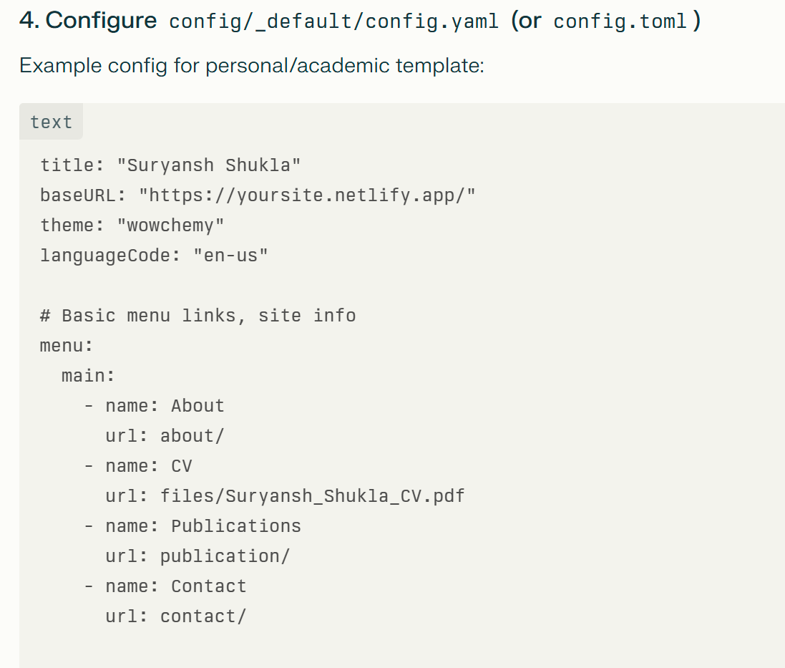

We still have the gallery and the weird buttons in there

* Remove those weird buttons
* First figure out the gallery button and then fix it there

Just one thing is unfixed i.e. the gallery